Assignment- 02
Create a table
1. Create a table students with columns: id (INT), name (VARCHAR, NOT NULL), and age (INT with default 18).
2. Insert into students: (1, NULL, 20). What will happen?
3. Insert into students: (2, 'Ravi'). What will be stored in age?

4. Why will the following query fail?
INSERT INTO students (id) VALUES (3);
5. Modify the students table so that the age column default changes from 18 to 21.

6. Drop the NOT NULL constraint on the name column. Write the query.

7. Create a table department with columns: dept_id (INT, PRIMARY KEY), dept_name (VARCHAR).
8. Insert (1,'IT') and (1,'HR'). What error will you get?

9. Can a table have two PRIMARY KEYS? Demonstrate with a query.
10. Create a table enrollment with composite primary key (student_id, course_id).

11. Try inserting (101, 'DBMS') twice into enrollment. What happens?’
12. Create a table users with columns: user_id (INT, PRIMARY KEY, AUTO_INCREMENT), email (VARCHAR, UNIQUE).
13. Insert ('abc@mail.com') twice. What error occurs?

14. Does the following query work? Why?
INSERT INTO users (email) VALUES (NULL);
INSERT INTO users (email) VALUES (NULL);


15. Create a table products with UNIQUE constraint on (sku, region).
16. Insert (sku='1', region=” Bengaluru') twice. What error?
17. Create a table department with primary key dept_id. Then create employee table with foreign key dept_id referencing department.
18. Insert into employee (emp_id=1, name='Asha', dept_id=99) when no such dept exists. What error?
19. Delete dept_id=1 from department when employees exist. What error without ON DELETE CASCADE?
20. Recreate employee table with ON DELETE CASCADE. What happens if you delete department 1?
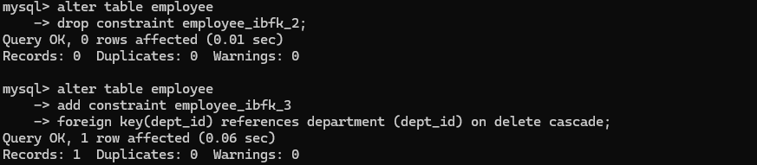
21. Use ON DELETE SET NULL in the foreign key. What happens when parent is deleted?
22. Write a query to drop a foreign key constraint fk_emp_dept.

23. Add a new foreign key constraint fk_manager in employee table referencing itself (manager_id).
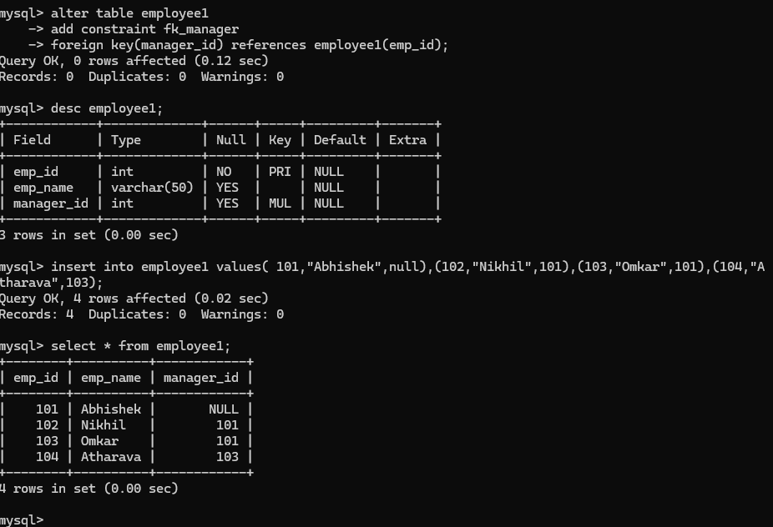
24. Create table accounts with balance >= 0 using CHECK.
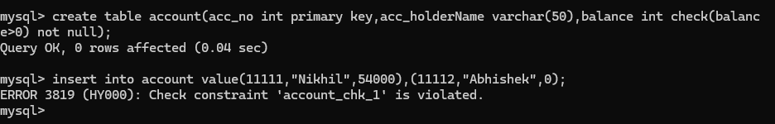
25. Insert (id=1, balance=-100). What happens?

26. Modify the constraint so that balance must be between 100 and 1,000,000.

27. Try to insert (id=2, balance=50). What error do you get?
28. Create table invoices with invoice_id AUTO_INCREMENT PRIMARY KEY. Insert 3 rows. What will be the IDs?
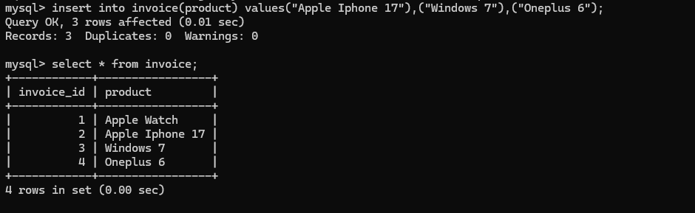
29. Delete last row. Insert again. Will AUTO_INCREMENT reuse the deleted number?

30. Write queries to:
- Add a UNIQUE constraint on the phone column in users.

- Drop the UNIQUE constraint from users.

31. Create a table library with a composite primary key (book_id, branch_id) and a UNIQUE constraint on (isbn, branch_id).

32. Insert (book_id=1, branch_id=101, isbn='A123') twice. What error occurs?\

33. Insert (book_id=1, branch_id=102, isbn='A123'). Will it work? Why?

34. Can you have a table with PRIMARY KEY and multiple UNIQUE constraints? Write a query.
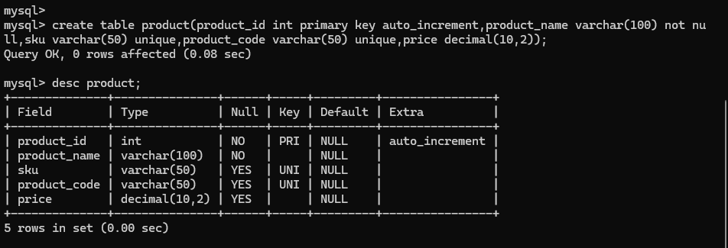
35. Try to create a table with both PRIMARY KEY(id) and UNIQUE(id). What happens?
When you try to create a table with both PRIMARY KEY(id) and UNIQUE(id) on the same column, the database will successfully create the table but will ignore the UNIQUE constraint as it is redundant.
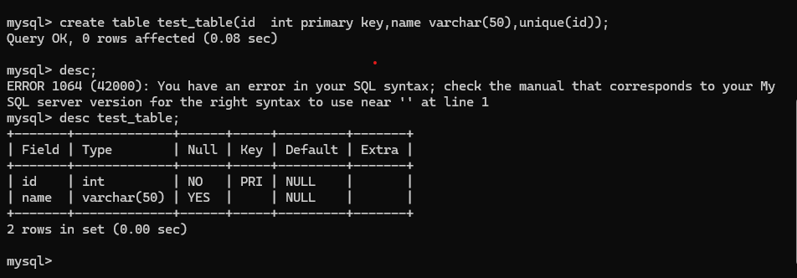
36. Create table exam_results with composite primary key (student_id, exam_id) and CHECK constraint marks BETWEEN 0 AND 100.
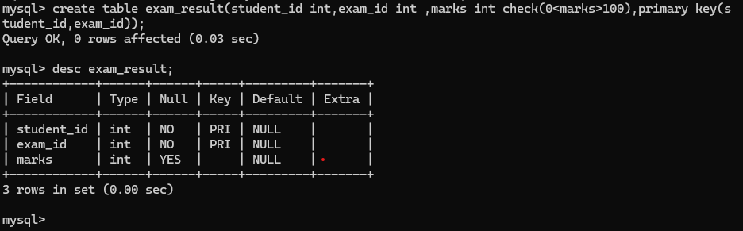
37. Create table orders referencing customers with ON UPDATE CASCADE. Update customer_id in parent – what happens in child?

The orders table is automatically updated. A SELECT * FROM orders; would now show that the customer_id for order 1 has also changed to 555.
38. Try to use ON DELETE SET DEFAULT in a foreign key. What happens in MySQL?
39. Create a self-referencing foreign key categories(parent_id) referencing categories(id). Insert parent and child categories.
40. What happens if you delete a parent row in categories without ON DELETE CASCADE?
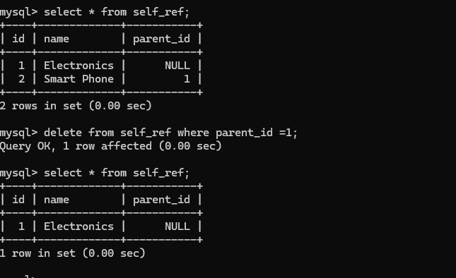
41. Write a query to temporarily disable foreign key checks and insert invalid data.

42. Write a query to re-enable foreign key checks.
43. Explain with a query why indexes are automatically created when foreign keys are added.
When you modify or delete a row in a parent table, the database must quickly check the child table for any related rows. Without an index on the foreign key column, the database would have to perform a full table scan on the child table every time. On large tables, this is extremely slow. The automatically created index allows the database to find matching child rows almost instantly, preventing performance bottlenecks.
44. Create a table employees with CHECK that salary > 20000.

45. Insert (id=1, salary=15000). What error code will you get?
46. Add a CHECK constraint on gender column so only 'M' or 'F' is allowed.

47. Try inserting gender='X'. What happens?

48. Add a foreign key constraint on employee.dept_id referencing department.dept_id.

49. Drop a primary key constraint from table library. What query do you use?

50. Rename a foreign key constraint fk_emp_dept to fk_employee_department.



